**How to Install VMware Workstation Pro Ubuntu 20.04**

**Step-1**

Update Operating System

Update your **Ubuntu** operating system to make sure all existing packages are up to date:



**Step-2**

Install Dependecies



**Step-3**

Download VMware Workstation 16 Pro

Visit the official [download page](https://www.vmware.com/products/workstation-pro/workstation-pro-evaluation.html) of VMware Workstation Pro, and select **“DOWNLOAD NOW”** under Workstation 16 Pro for Linux.

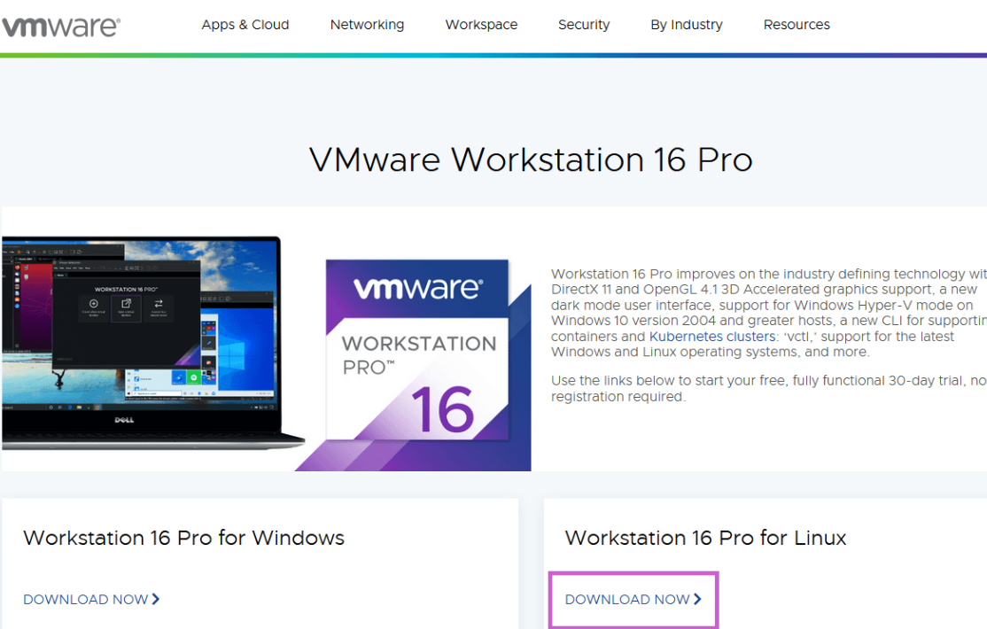

Select “Save File” and hit ok.

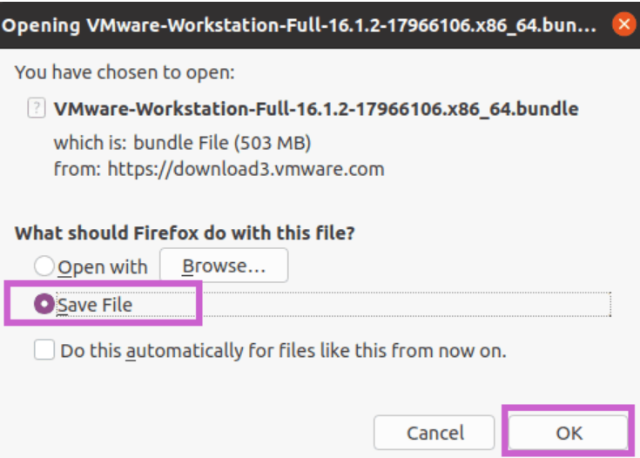

**Step-4**

VMWare Workstation Bundle Permissions

Once you have completed the download, open the directory you have downloaded the bundle file. Usually, this would be in your downloads directory, and we will make it executable with the following command.



The file should have the permissions of **“-rwxrwxr-x”**, which you can confirm with the following command.





**Step-5  
Install VMWare Workstation Pro 16**

The final part of the installation is to proceed with the following install command.



Once completed, you will see an output as below.

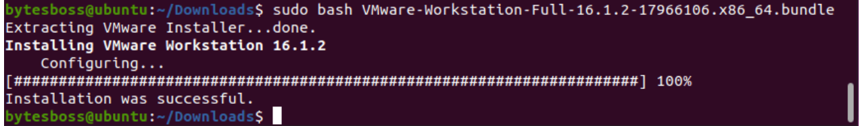

**Step-6**

**Launch & Complete Setup of VMware 16 Pro**

Next, we go to find VMWare Workstation located in Ubuntu’s application menu.

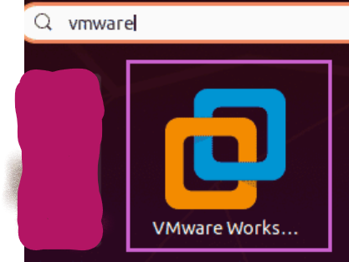

Click **VMware workstation**. Next, it will take you to the initial setup and agreements. Select accept terms and hit next.

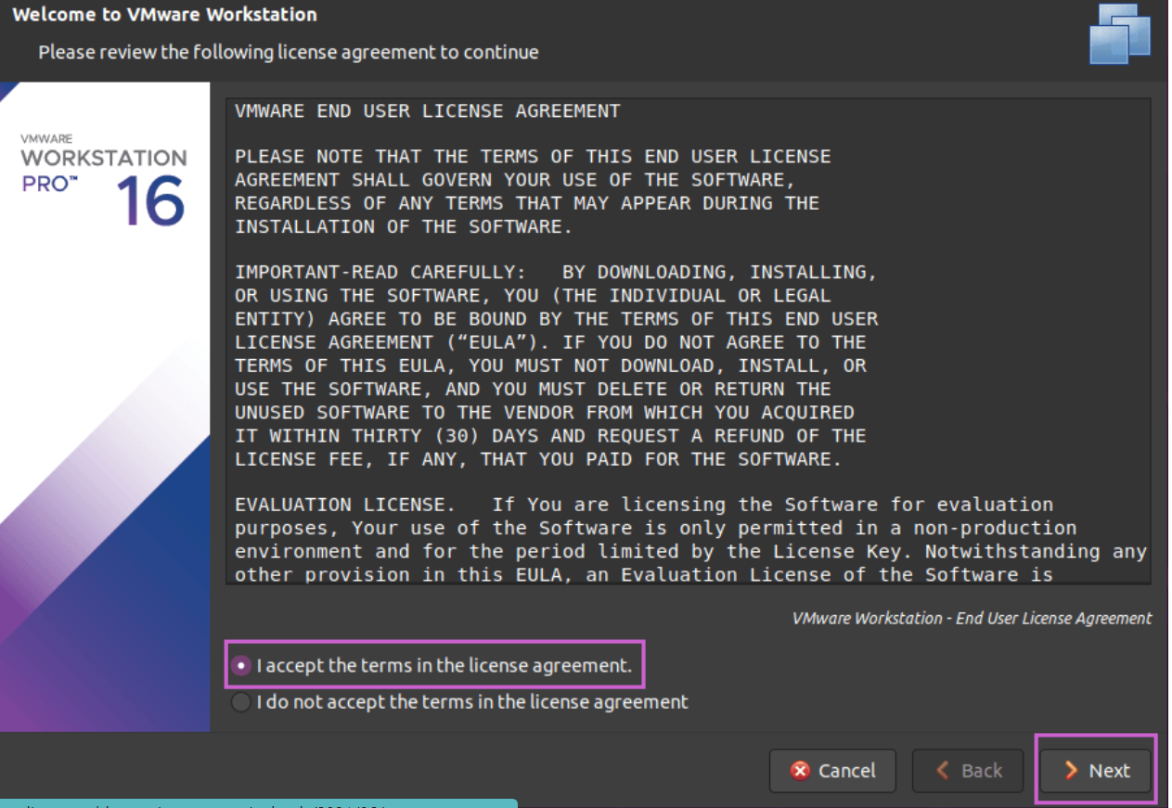

Now, a second license agreement comes up. Agree as above and hit continue. You will then check for products upon startup. This should be left as default and on.

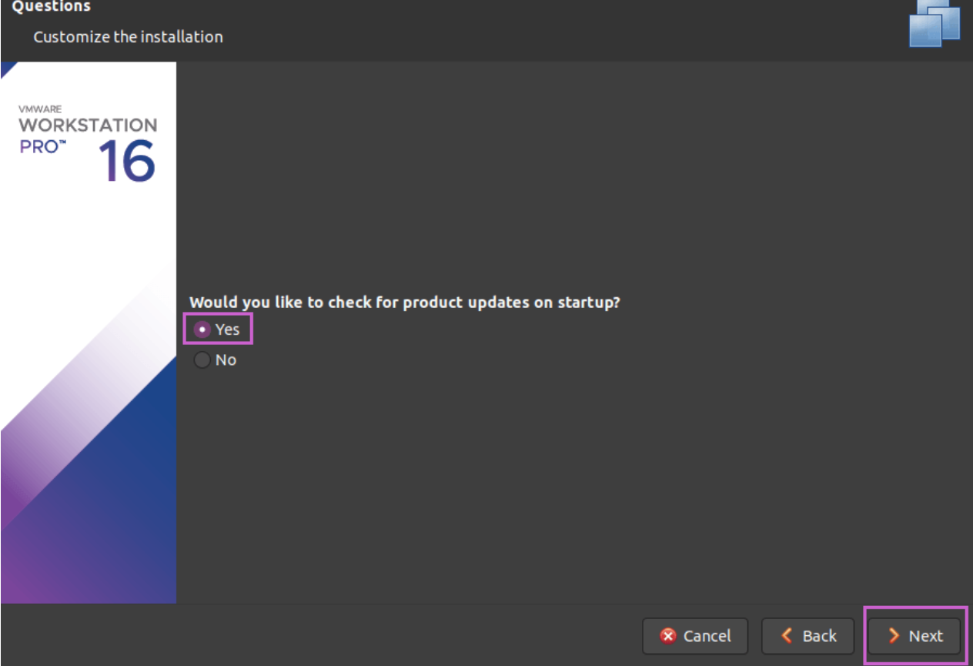

VMware’s customer experience improvement program features next, select yes or no, then hit next.

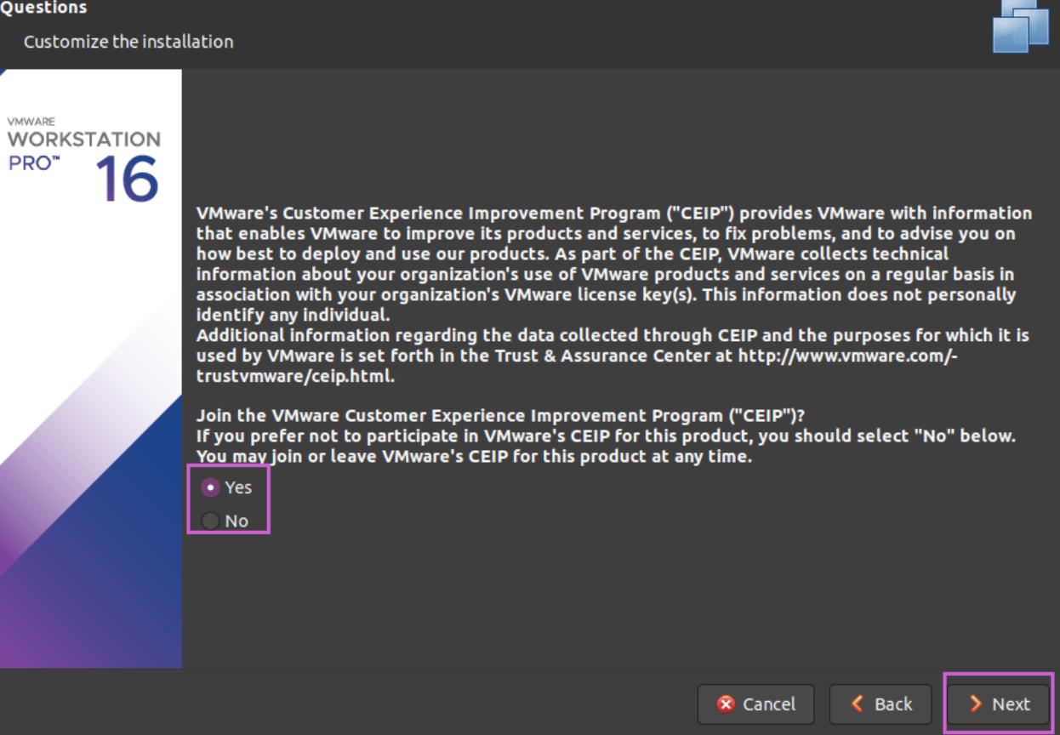

Enter your product key, trial out VMware Workbench 16 Pro for 30 days, and then hit finish.

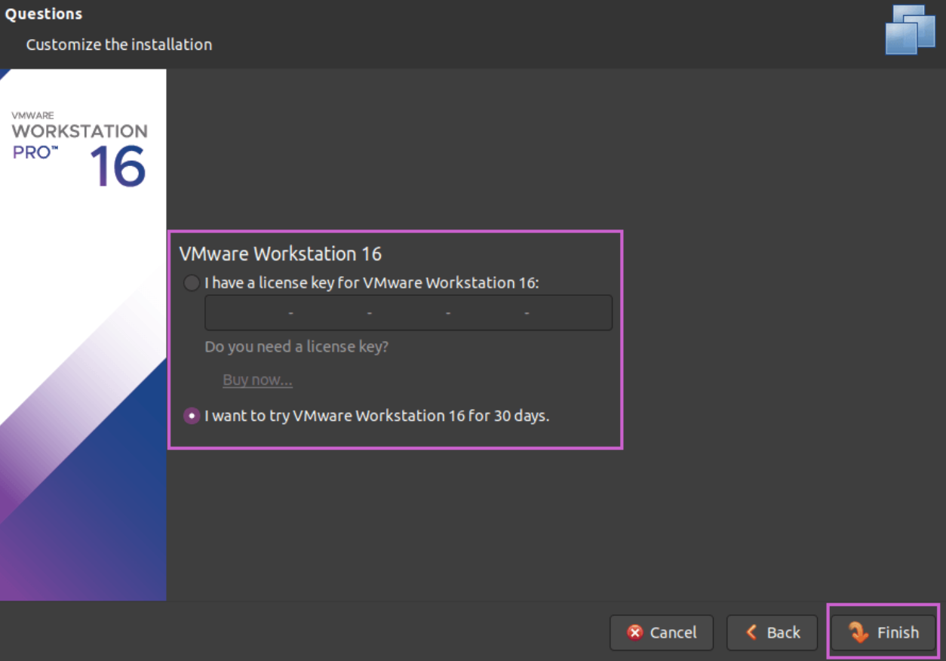

The install is complete, and VMware Workstation pro 16 will open